ABDULLAH ALAHMADI

ToDoList Project

{Phase 2}

|  |  |
| --- | --- |
| App.js | Import AddTask , ItemTask |
| AddTask.js | Used to add task |
| ItemTask.js | Use to remove and complete tasks |
| Reducer.js | Use to store data in store |
| ActionsType.js | Use to define type |
| Github repo link | [Link](https://github.com/AbdullahYasser1/ToDoList_React_Project) |

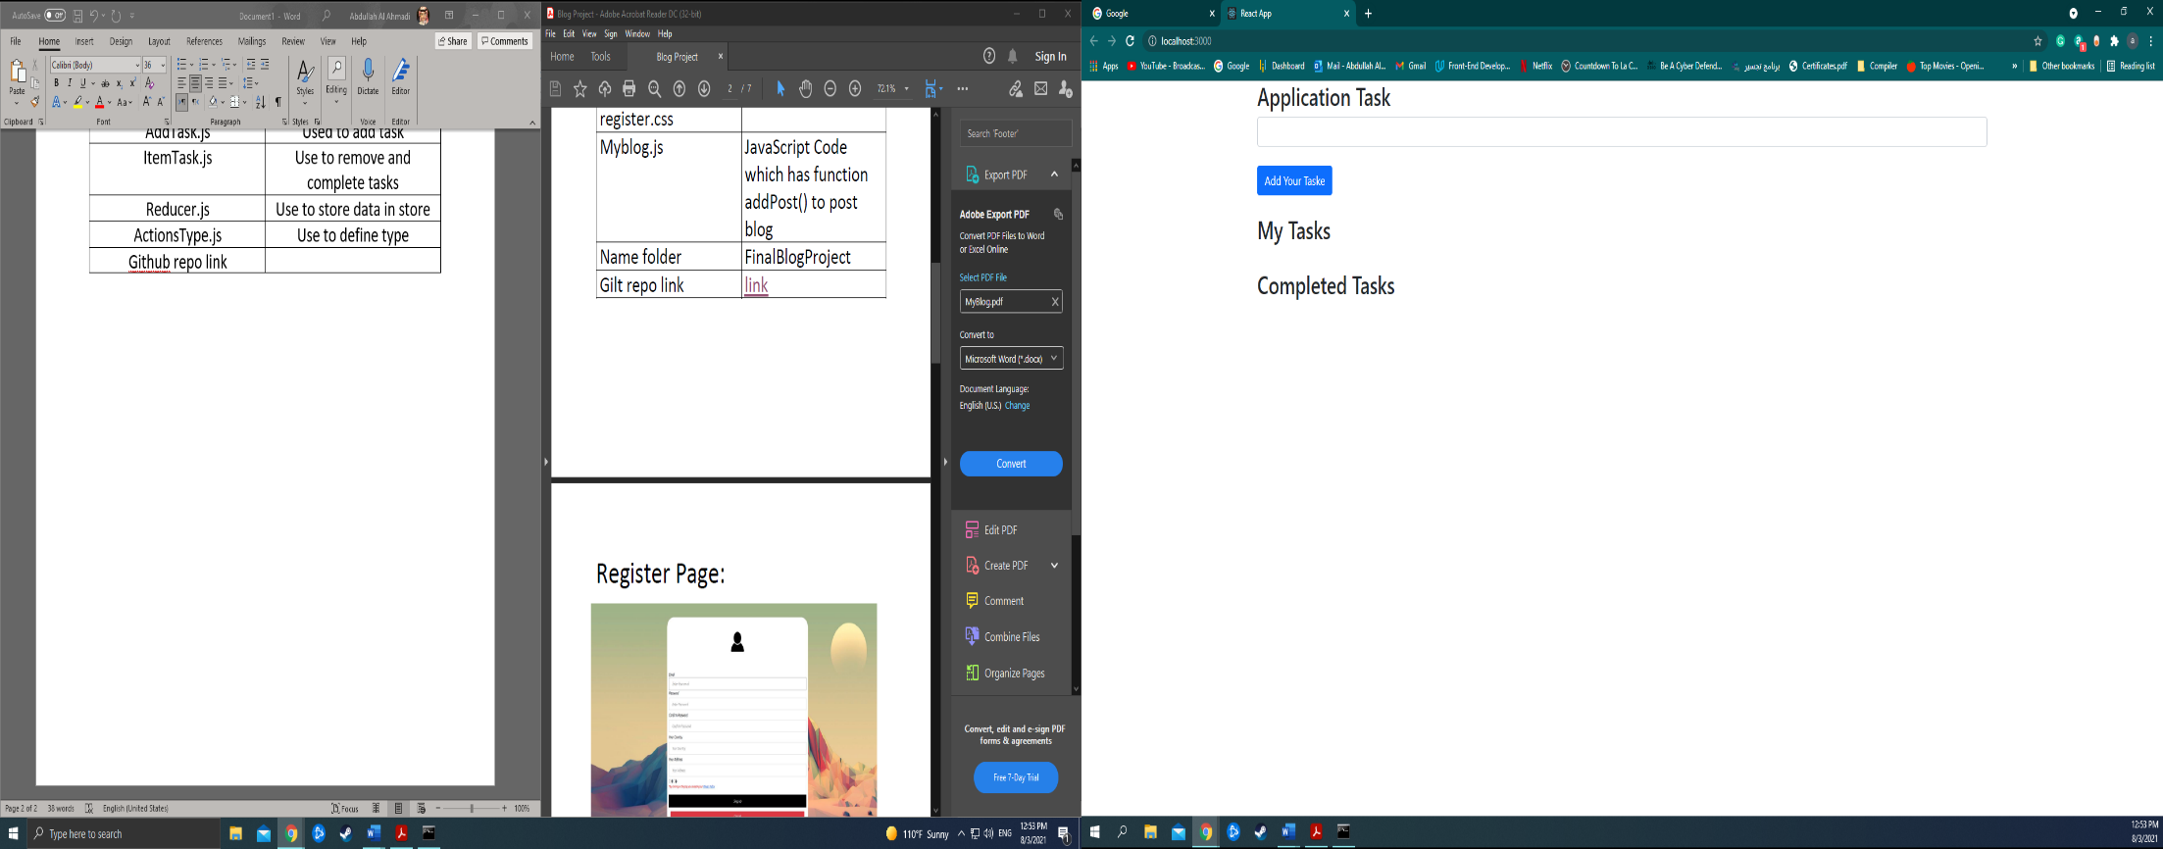Application Task Page

User Input a Tasks

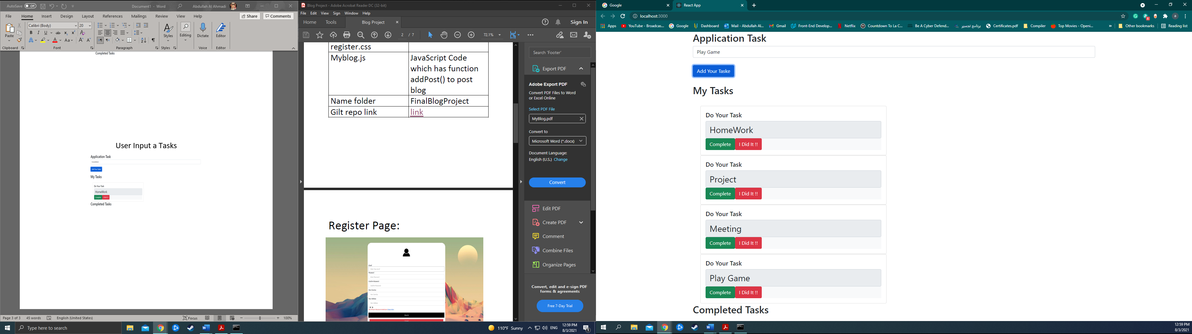

User Complete the Homework Task

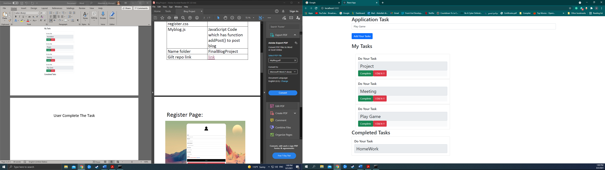

User Delete the Play Game Task

